

**Ankara Yıldırım Beyazıt University**

**MIS204 Project Assignment**

**WRISTBANDAPP DATABASE MANAGEMENT SYSTEM**

**Project Members**

1-) Muhammet Ali AMANVERMEZ – 19030411007

2-) Serdar YILDIZ -19030411010

3-) Meryem Kevser EMİR - 19030411038

4-) Yunus Emre ULUSAN - 19030411029

5-) Ersel DİNÇKAYA - 19030411045

Table Of Contents

Wristband Database Management System……………..1

Table Of Contents……………………………………………………2

Report …………………………………………………………………….3

Business Rules ………………………………………………………..4

ER Model…………………………………………………………………5

ERM Model……………………………………………………………..5

Relationship Schemas……………………………………………..6

NF Transformation………………………………………………….7

Table Output Code………………………………………………….10

SQL Queries…………………………………………………………..14

Data Dictionary………………………………………………………24

**DATA REPORT**

**Although we sincerely want this situation to end, unfortunately, we are faced with many people who do not comply with the measures taken at the beginning of this, there are citizens who leave home, even though they are sick. In terms of preventing this, we thought of a wristband this practice is actually done in some countries, but it has not yet operated in our country. We have compiled a sample of the data that will be required if it operates. The main goal here is to track the patient's condition and location thanks to the wristband. Thanks to this bracelet, which is worn on people who are sick or have contact with the patient, we will be able to reach their position and condition comfortably.**

**First, we set colors for the bracelet, our goal was to Group sick people more comfortably. If we open the sentence, as you know, this disease spreads on contact and needs to be detected in people with contact, so people with contact also need wristbands, but not all patients with contact are positive. That's why we make color separations. The color distribution is as follows on the bracelet:**

**Red: person directly infected with the virus (covid-19 patient )**

**Yellow: a person who is indirectly infected with the virus ( contact)**

**Green: a person who has no contact with the virus in any way.**

**Second, we have identified the hospitals where the wristbands will be given and in which area these hospitals are located. Our goal here was not to have trouble tracking the wristband (knowing the hospital where it was given) and to be able to track the case situation in the regions. In order for this to be more systematic, we first identified the business rules and wrote them in articles. By further detailing the data, we have added the area where the patients are and the people who work in the hospital to this data pool. Thanks to employee identification, it will be clear who gave the bracelet, and the doctor in the hospital will more easily detect the condition of the patient.**

**Third, we created the tables. In the tables, we determined the relationships between the data. The tables indicate multiple relationships, NF relationships, and data subtypes between them. Data details are clearly stated in the tables. It then encodes the tables and SQL QUERIES follow. Finally, we have added a data dictionary for data intelligibility.**

**In short, a wristband database management system was examined within the scope of the project and the results were written and the project was terminated . The project was also used in SQL and MS SQL. For this project, we gathered online every day at 22:00 - 23:59.**

**BUSINESS RULES**

**1-)** The employees in the hospital: doctors, nurses, cleaners, security guards, directors, secretaries.

**2-)** The hospital_id , region_id, wristband_id are recorded in the hospital management system.

**3-)** Every hospital has a certain number of wristbands.

**4-)** There must be more than one hospital in each region.

**5-)** Each hospital can belong to only one region.

**6-)** A wristband can only belong to a hospital.

**7-)** There may be a mutation in a patient. There can be not more than one mutation.

**8-)** There are 5 different types of mutations in total. These are British, Chinese, Brazilian, South African, Indian.

**9-)** Each bracelet color shows the patient's situation.

**10-)** There are 3 colors in the bracelet. Red: sick, yellow: contacted, green represents healthy individuals.

**11-)** HES Code and wristband id are linked to each other.

**12-)** There are 7 regions in the regions table.

**13-)** Each patient's name, surname, region, hospital, variant type, wristband color, examination date and HES code are registered in the system.

**14-)** The wristband cannot be removed from the wrist during the quarantine period (14 days).

**15-)** Hes codes must be 12 digits. (12 characters including hyphens) For example: "ERS7-4P5T-72".

**16-)** Regions are divided into four as Risky, Medium Risk, Low Risk and Safe according to the Covid risk group based on the number of sick people they host.

**17-)** The location and the status of the bracelet are obtained from the user of the bracelet.

**ER MODEL**

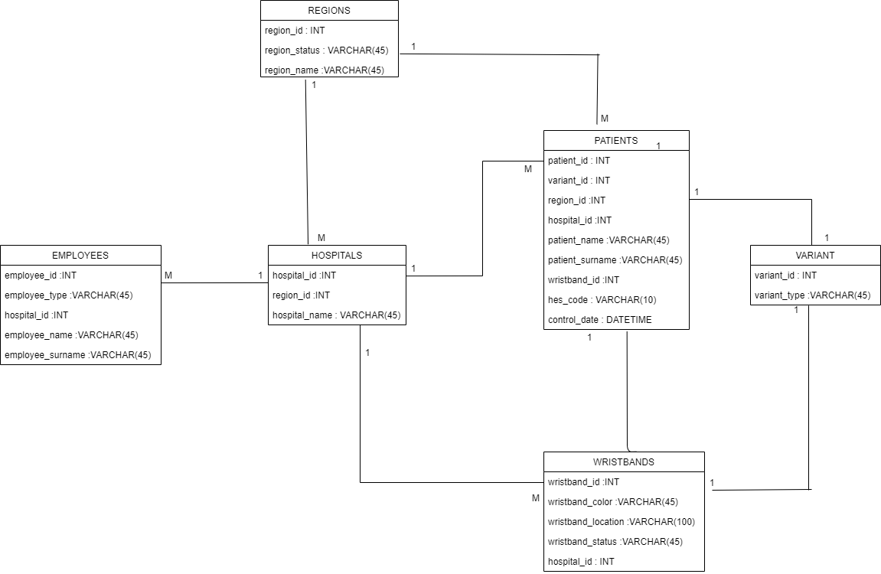

**ERM MODEL**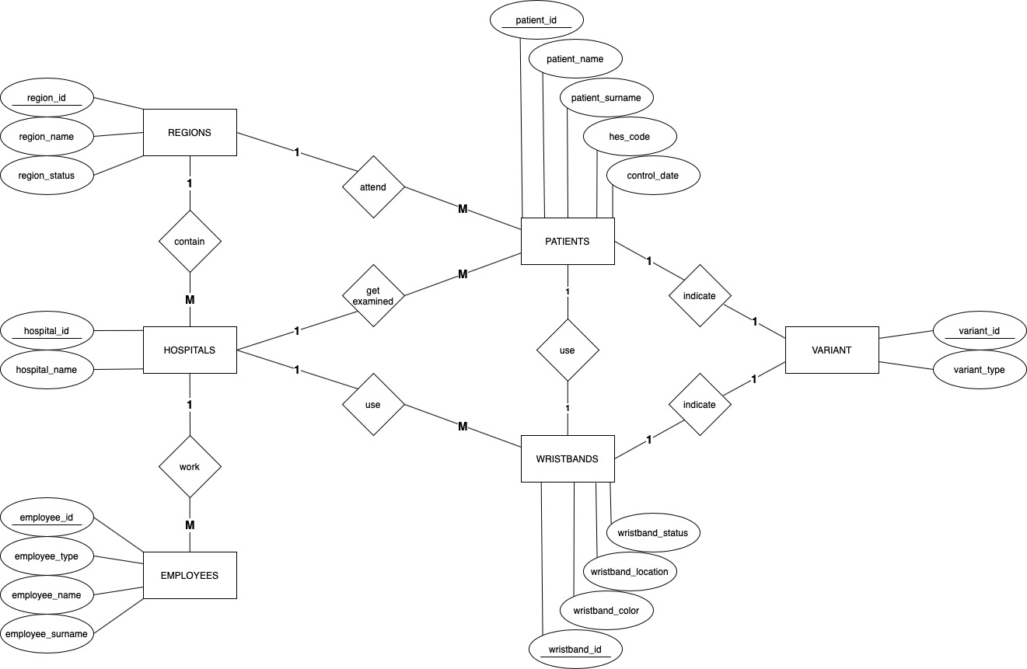

**Relationship Schema**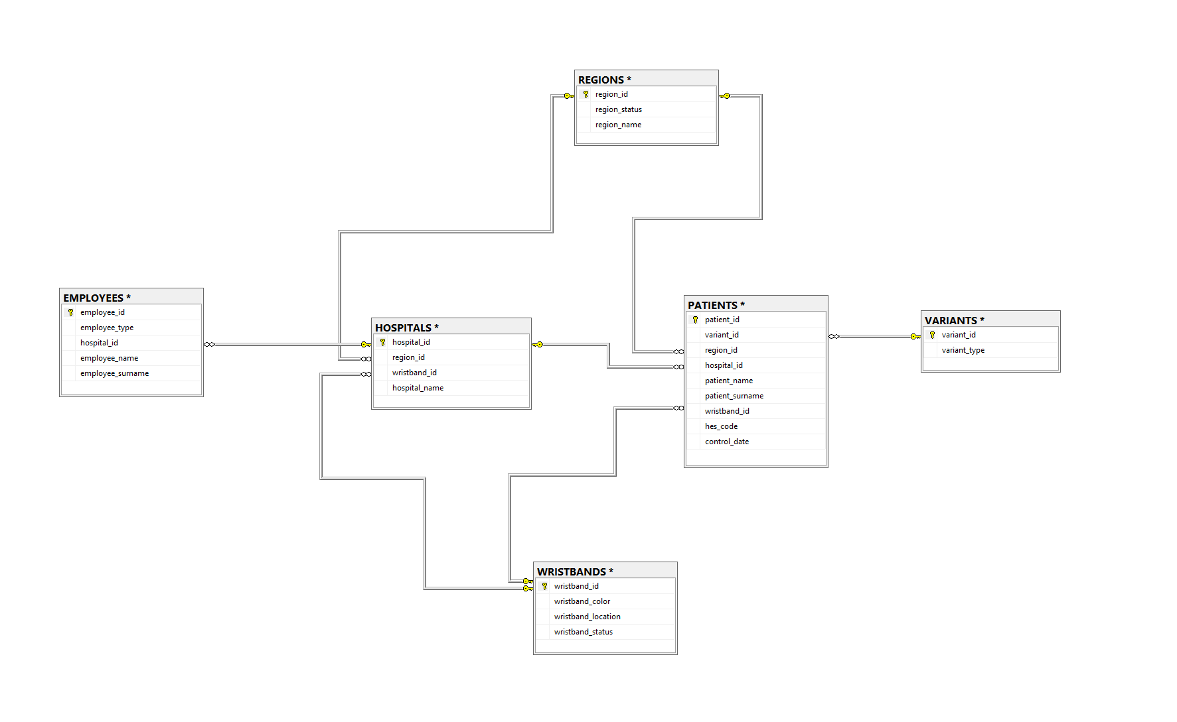

**Relationship Schema 2**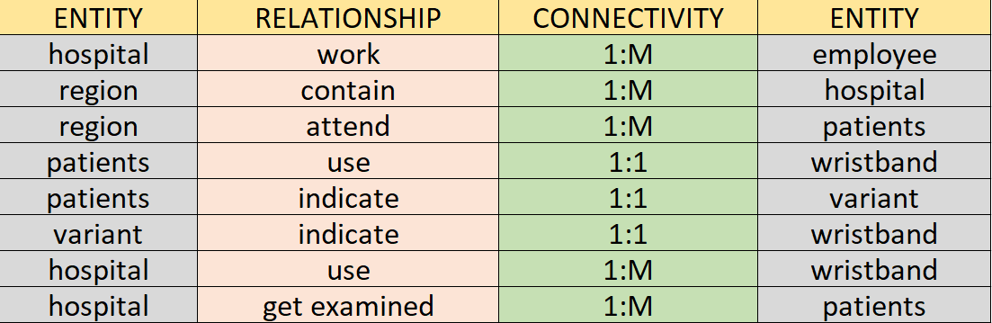

**NF Transformation**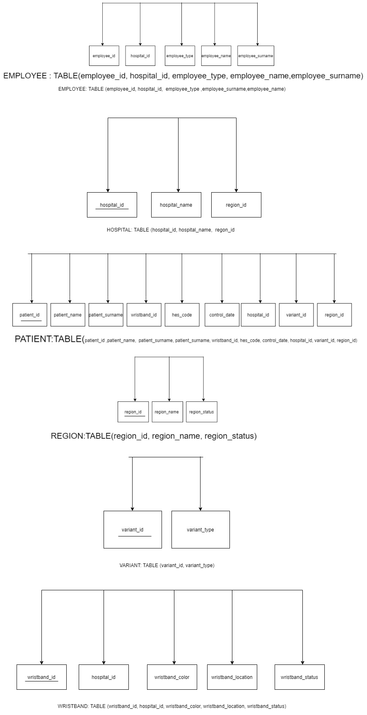

**2NF Transformation**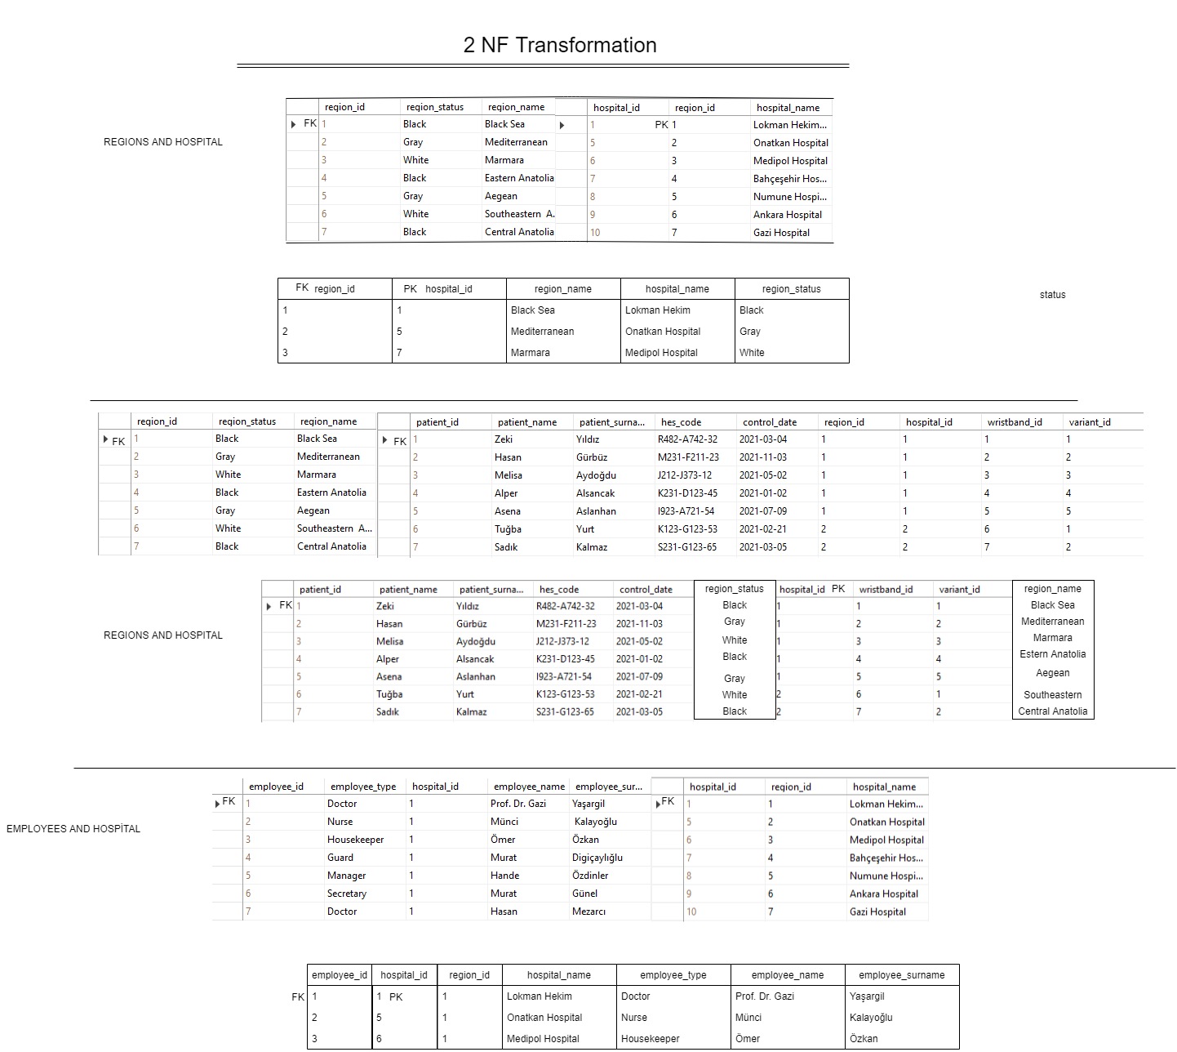

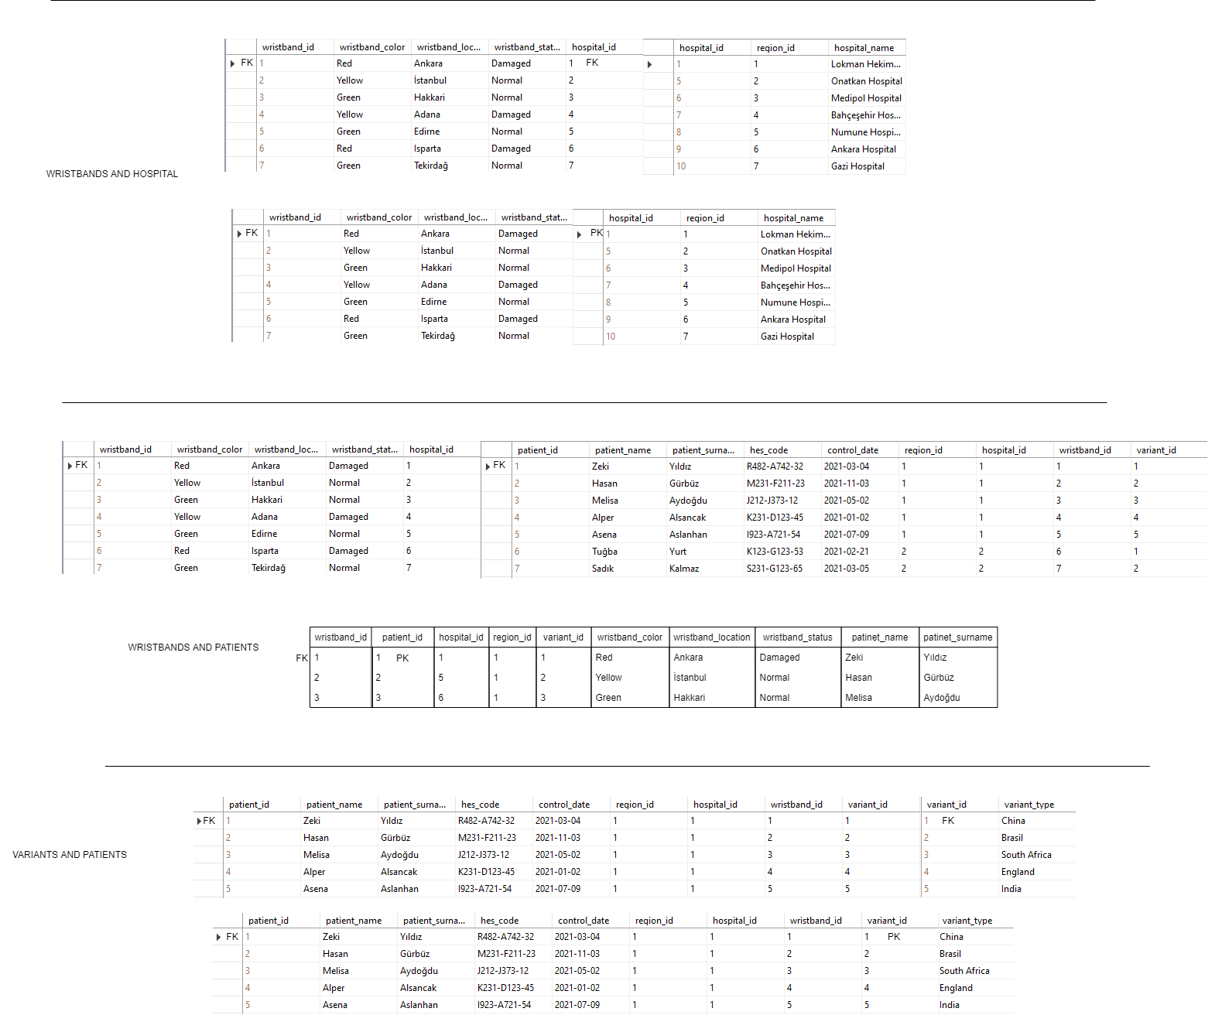

**Table Output Code**

CREATE TABLE REGIONS(

    region_id int Primary Key,

    region_status NVARCHAR(45)

    region_name NVARCHAR(45),

);

SELECT TOP (1000) [region_id]

,[region_status]

,[region_name]

FROM [CovidDb].[dbo].[REGIONS]

-------------------------------------------------------------------------------------------

CREATE TABLE VARIANTS(

    variant_id int Primary Key,

    variant_type NVARCHAR(45)

);

SELECT TOP (1000) [variant_id]

,[variant_type]

FROM [CovidDb].[dbo].[VARIANTS]

CREATE TABLE EMPLOYEES(

    employee_id int Primary Key,

hospital_id int,

    employee_type NVARCHAR(45),

    employee_name NVARCHAR(45),

employee_surname NVARCHAR(45) );

SELECT TOP (1000) [employee_id]

,[employee_type]

,[hospital_id]

,[employee_name]

,[employee_surname]

FROM [CovidDb].[dbo].[EMPLOYEES]

CREATE TABLE HOSPITALS(

    hospital_id int Primary Key,

region_id int,

    hospital_name NVARCHAR(45)

);

SELECT TOP (1000) [hospital_id]

,[region_id]

,[hospital_name]

FROM [CovidDb].[dbo].[HOSPITALS]

CREATE TABLE PATIENTS(

    patient_id int Primary Key,

region_id int,

variant_id int,

hospital_id int,

wristband_id int,

patient_name NVARCHAR(45),

patient_surname NVARCHAR(45),

hes_code NVARCHAR(12),

control_date TIMESTAMP

);

SELECT TOP (1000) [patient_id]

,[variant_id]

,[region_id]

,[hospital_id]

,[patient_name]

,[patient_surname]

,[wristband_id]

,[hes_code]

,[control_date]

FROM [CovidDb].[dbo].[PATIENTS]

CREATE TABLE WRISTBANDS(

    wristband_id int Primary Key,

wristband_color NVARCHAR(45),

    hospital_id int,

wristband_location NVARCHAR(100),

wristband_status NVARCHAR(45),

);

SELECT TOP (1000) [wristband_id]

,[wristband_color]

,[wristband_location]

,[wristband_status]

,[hospital_id]

FROM [CovidDb].[dbo].[WRISTBANDS]

**SQL QUERIES**

**1-)**

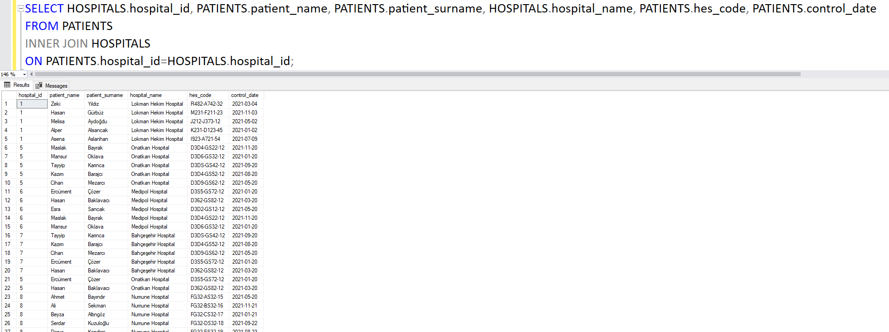

**2-)**



**3-)**

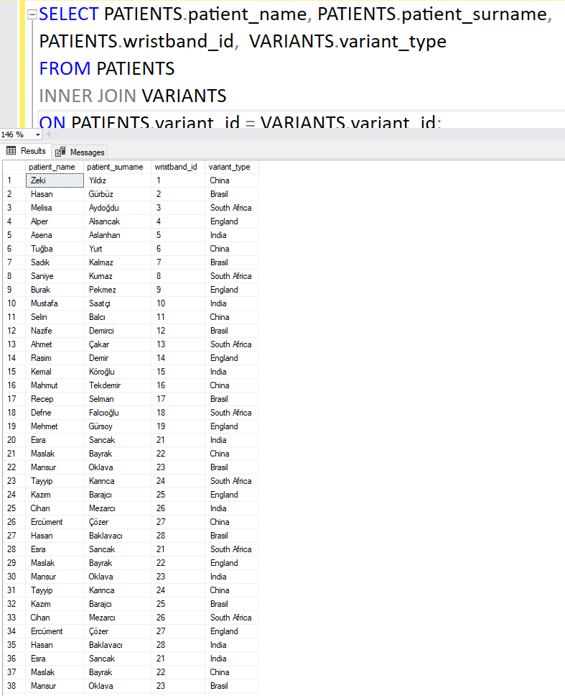

**4-)**



**5-)**

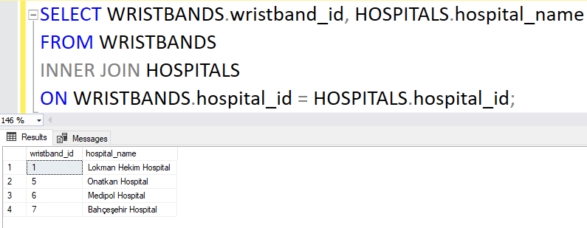

**6-)**

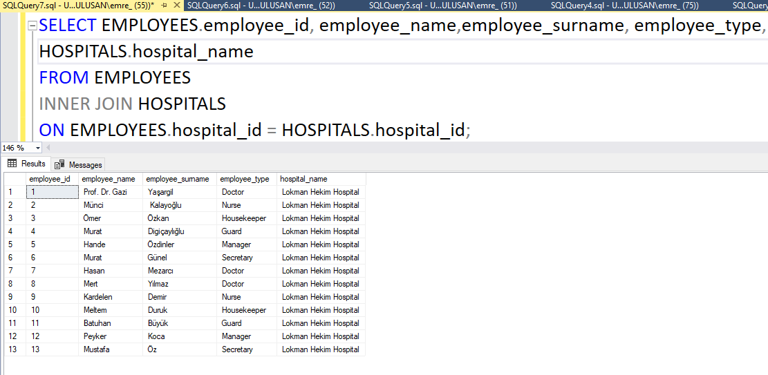

**7-)**

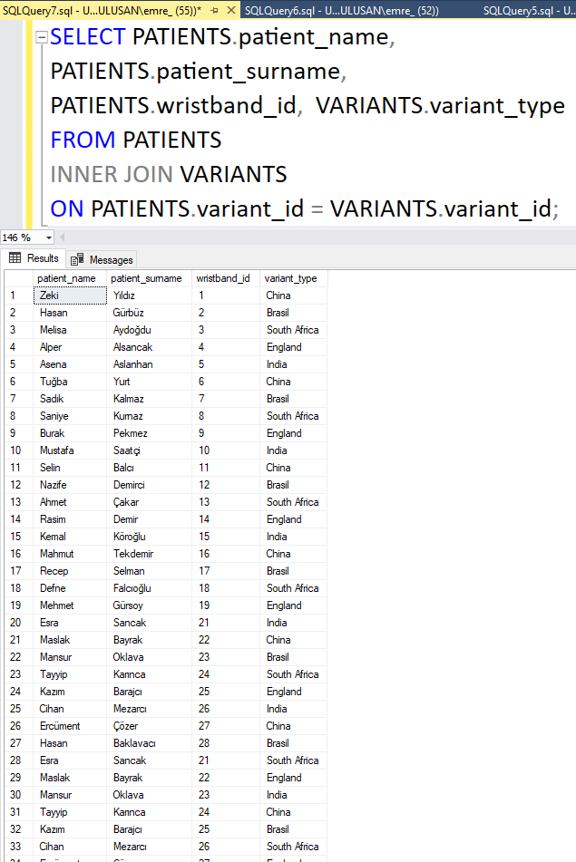

**8-)**

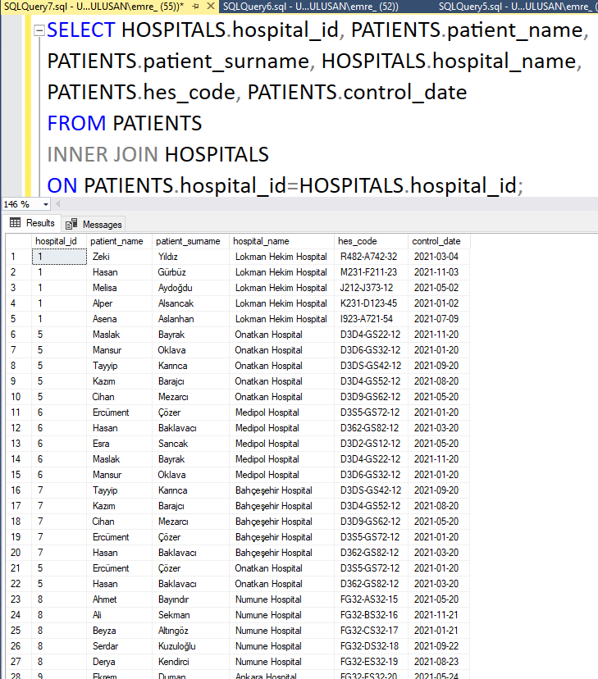

**9-)**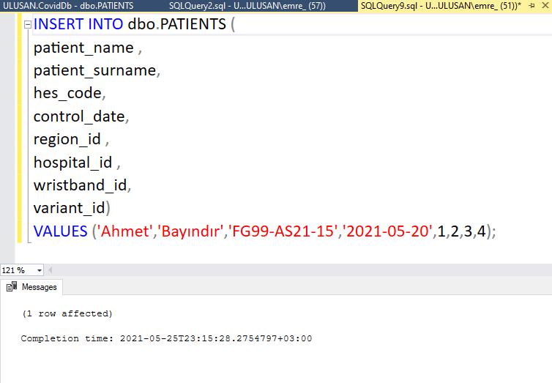

**10-)**

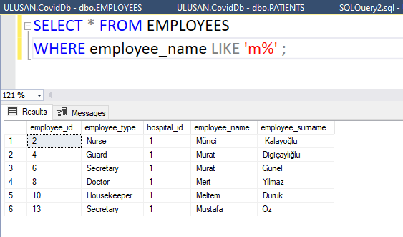

**11-)**

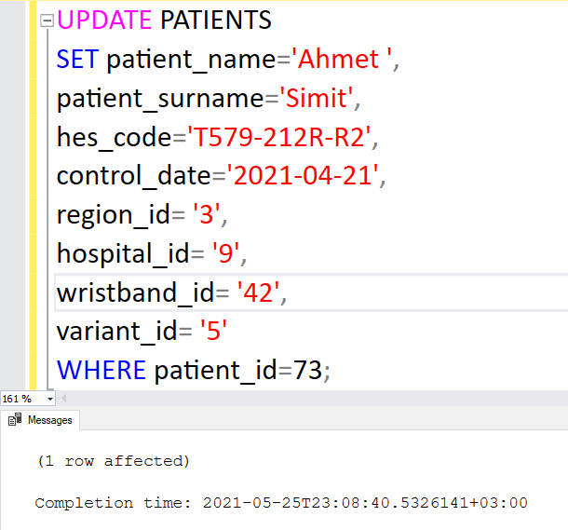

**12-)**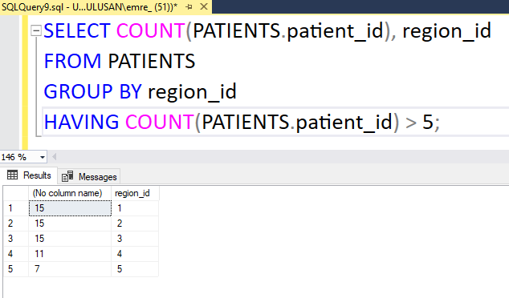

**13-)**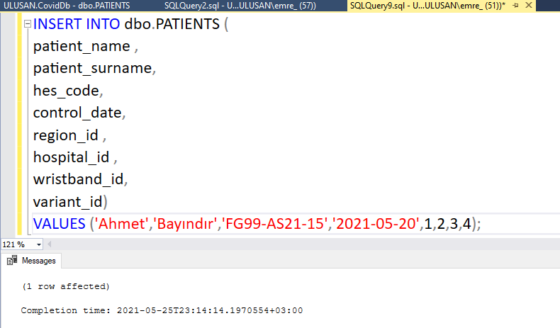

**14-)**

**15-)**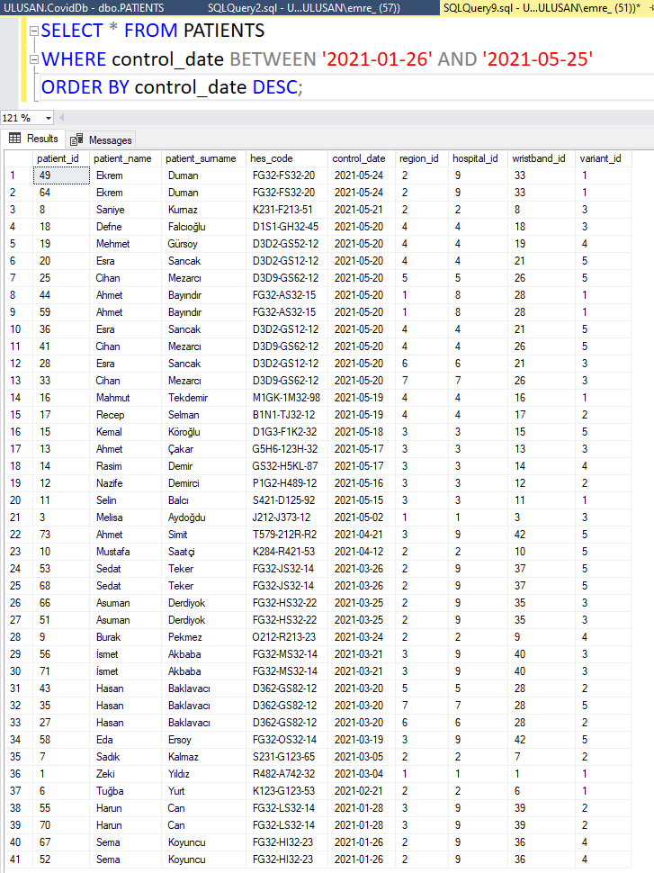

**16-)**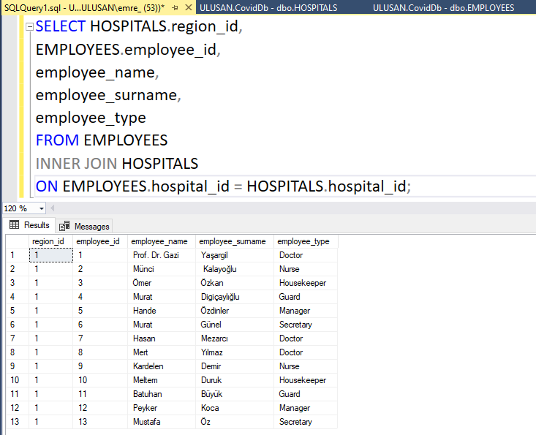

**DATA DICTIONARY**

